Getting Ready for School Checklist
I can...
I can...
I can...

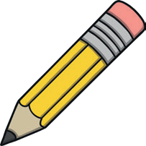
recognise my name write the first letter
I can...
I can...
I can...

count from 1 to 10
count accurately
1 2 3 4 5
I can...
I can...
I can...

eat with a knife and fork taste different foods
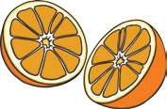
wash my hands before and after meals
I can...
I can...
I can...

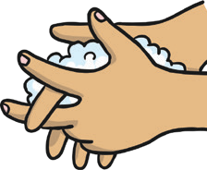
wash my hands dry my hands
hold my pencil carefully draw a face
share toys with a friend
go to the toilet when I need to
colour in carefully name the colours I use

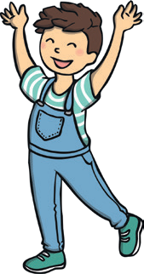
sing simple rhymes sing and clap to a song
move to music

tidy away my toys

clear away things I’ve used

use the stairs hand rail hold hands on the street take turns when playing
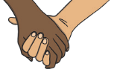
put on my socks find my shoes put on my shoes do up my shoes

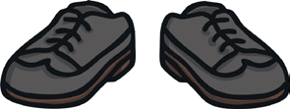
put my coat on
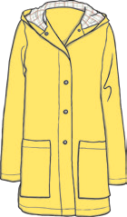

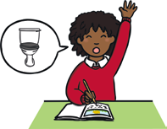
say please when I ask say thank you when I get ask to go to the toilet wait my turn to talk

cut along a line

cut ‘snips’ into paper

